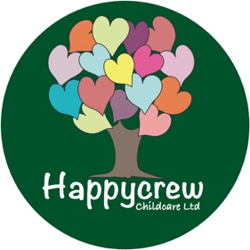

Complaints Policy

As a registered childminder working for Happycrew Childcare Ltd, I aim to work in close partnership with all parents, to meet the needs of their children.

I hope that you are happy with the service that I provide, but I appreciate there may be times when you feel that I am not offering you and your child(ren) the service that you require. I hope that you will feel able to discuss any concerns or issues that you may have with me directly. If you would rather not talk in front of your child(ren) then we can arrange a more convenient time, for example in the evening or at the weekend. I will make every effort to resolve the issue. If you prefer, you can put the complaint formally in writing or by email to me. I have a mandatory duty to investigate all complaints relating to the EYFS Welfare Requirements for childminding.

Depending on the nature of the complaint, I will investigate myself or it will be passed on to Rutland to investigate. Complaints will be treated sensitively. Under the requirements of the Early Years Register and the Childcare Register you will be notified of the outcome and receive a copy of any written records regarding the complaint within 28 days.
I will keep a written record of all complaints. It will remain confidential unless an Ofsted inspector asks to see it. I will record the following:

    - Name of person making the complaint.
    - Nature of the complaint.
    - Date and time of the complaint.
    - Action taken in response to the complaint.
    - The outcome of the complaint investigation (for example, ways the service has improved).
    - Details of the information and findings that were given to the person making the complaint (which should have been provided to them within 28 days), including any action taken.

I will also keep a summary of the complaint to provide on request to any parent of a child for whom I act as a childminder and Ofsted. This summary will not include the name of the person making the complaint. Records will be kept for 3 years.

If you feel that you are unable to talk to me or that after talking the matter remains unresolved, then for impartial advice you can talk in confidence to The Early Years Childminding Team on 0208 464 9037

If you wish to make a formal complaint, then you can contact the Ofsted Complaints and Investigation Unit on 0300 123 1231.

If you wish to make a complaint to my Agency

The Agency contact details are as follows:

Telephone: 07908882120 for complaints
Post: Rutland Early Years Agency Ltd,
Complaints Dpt,
2 Market Street, Oakham,
Rutland, LE15 6DY.

My REYAL registration number is: RA000928

GDPR May 2018

If you wish to make a complaint regarding a data breach or if you think I am not processing your data appropriately you can contact the Information Commissioners Office – https://ico.org.uk/for-organisations/report-a-breach/

